Booking Software

- RECTIFICATIONS
  - Calendar :
    - Add reference no in Dashboard (In Cal)
    - Error on Calendar
  - Electricity meters:
    - Provide 2 for each daily bill
    - Separate for Van
  - Daily Billing:
    - Last date Electricity billing issue (More than 1 Bill daily??)
  - Adding New Sets?
- Reports
  - Existing Daily Reports
  - Audit reports
    - Missing Daily Billing
    - Missing Invoicing
- Accounting
  - Bhawani Daily Debtor Report
  - Party wise Report
  - TDS management
  - End of booking reports
- Daily Booking intimations to various departments
  - Housekeeping (facilities)
  - Security (print / email / pc?)
- Electricity Reconciliation (module)
- Terms & Conditions
  - To only keep latest Version along with Version dd.mm.yyyy. Tag. (Booking Date / Schedule Date ?)
  - Do not Keep Old Terms and conditions
Existing Corrections
Existing Extension
Accounting
Debtor Report: Select Customer, Show Open Bookings, Enter TDS, Calculate Total, Enter Receipts, Calculate Balance, Mark “Closure of Booking”
Report of Party wise Report, Booking wise Report, Show in Summary Report
Electricity

Debtor Report
Identify balance of customer.
Maintain schedule wise tally of payment.
Generate debtor report.
Workflow
Party books location for shooting. The party pays advance. On daily basis pays rent. The party pays with deduction of TDS. M/s Ellora will check 26AS. M/s Ellora will enter generate daily payable and enter amount received from the party. The party will
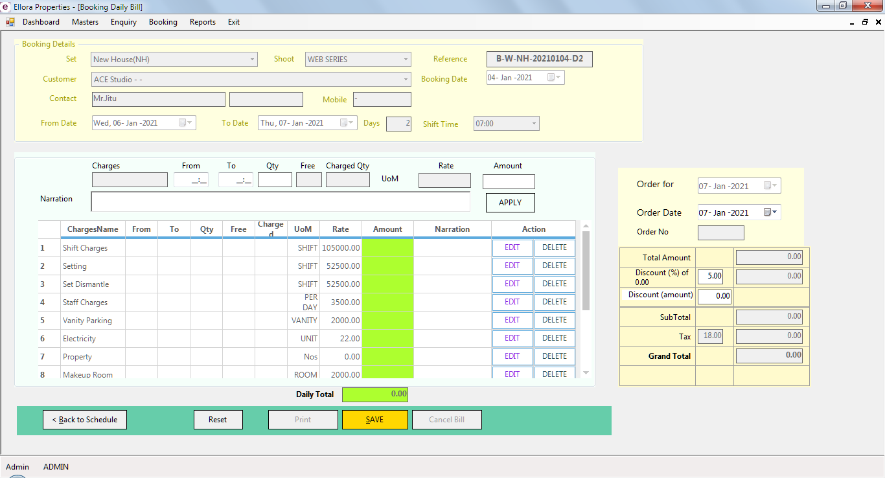
SELECTION OF PARTY BILLS
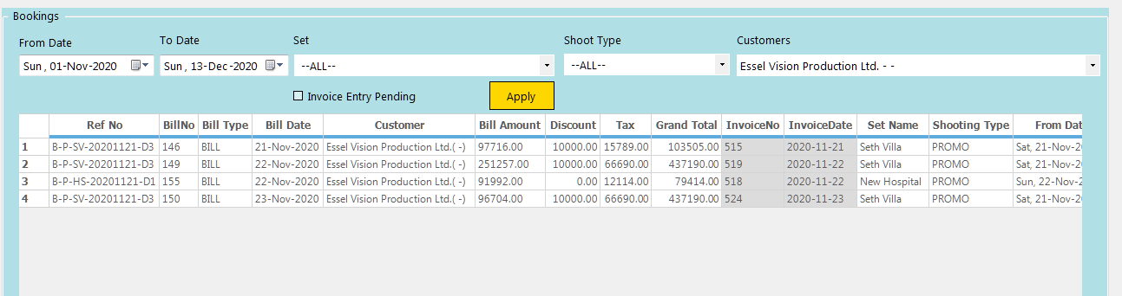
- Batch MASTER – Batch DETAILS
- Batch DETAILS - TDS Entry in Cell and calculate amount receivable.
- Batch Master - Entry of Receipts Below this GRID, amount, Payment mode, date
- BATCHWISE saving of data.
- Closure of Booking By the USER.

